CS-003 Mold Design & Manufacturing
Doc ID | CS-003
Title | Mold Design & Manufacturing (Tooling Board)
Revision | D
Status | Draft, pending Lead signature
Effective date | 2026-08-28
Supersedes | Tribal mold-design practice; consolidates SN4 Mold Manufacturing Problems and Solutions + Mold Design Documentation

Approvals
Role | Name | Date
Author | Simon Starbuck (drafted with Claude, SN6 Resources) | 2026-07-12
Reviewer | simon (reviewer agent)
Approver (Composites Lead)

Revision history
Rev | Date | Author | Description of change
A | 2026-07-12 | Claude | Initial issue
B | 2026-07-28 | Claude | Language pass: fewer em dashes for rhythm variety, no content change.
C | 2026-08-03 | Claude | Glue-up marking made explicit in §7.3: oil-based paint marker on two adjacent side faces, not a Sharpie, which the process's own IPA wipe dissolves (CS-001 §7.4).
D | 2026-08-28 | Claude | Engineering pass (CS-000 Rev C conventions). Figure 1 dimensions the §7.1 design rules on a mold cross-section, which is the form the §7.2 reviewer actually checks them in. No rule changed.

1. Purpose
A mold error you find after machining burns our three scarcest things at once: tooling board, machine time, and calendar. The SN5 clamshell CAD error (raised middle section, Feb 2026) forced a re-glue and re-machine and killed a week of slots in our tightest month (PP-03). This doc collects our mold design rules and adds the one check that would have caught it: someone who didn't design the mold reviews it before any board gets glued or cut.

2. Scope
Female/male molds machined from polyurethane tooling board (30–60 lb/ft³) for infusion and wet layup. Appendix A covers 3D-printed compression (forged CF) molds. Hotwire foam molds: out of scope (own project doc until standardized).

3. References
Ref | Document | Where
R1 | Ure-Bond 90 technical bulletin + SDS | 04 Datasheets/URE_BOND_90_TB.pdf, 1386A_2-1386B_2.pdf
R2 | SN4 Mold Manufacturing Problems and Solutions (2025-10-12) | SN5 Composites/Documentation/SN4 Mold Manufacturing Problems and Solutions.docx
R3 | Mold Design Documentation (wing mold CAD process + videos) | SN5 Composites/Documentation/Mold Design/Mold Design Documentation.docx
R4 | PP-03 RCA | FEB-COMP-PP-001
R5 | CS-005 (machining), CS-004 (sealing) | this series
R6 | Rohacell IG-F TDS (pressure/temperature limits for foam cores in molds) | 04 Datasheets/ROHACELL_IG_F_2022_April_EN_243534.pdf

Why Ure-Bond 90: SN4's board-stacking method (vacuum-bag with laminating resin) was slow and resin-hungry (R2). Ure-Bond 90 (R1) is a purpose-made rigid urethane adhesive: strong bond between boards, ~4 h clamp time, no bagging. Dowels + spot resin remain acceptable for very large stacks where adhesive cost bites.

4. Definitions
- Flange: flat margin around the part cavity for tacky tape, infusion lines, and trimming reference.
- Scribe line: machined V-groove marking the part trim boundary and datums.
- Stack (mold stock): tooling boards glued into a block thick enough for the mold.
- Max-Z: the machine's maximum cut depth; molds taller than max-Z must be split into sections with alignment datums.

5. Equipment & Materials
Item | Spec / product | Source | Notes
Tooling board | PU, 30 lb/ft³ general / 60 lb/ft³ fine-finish | Coastal Enterprises (sponsor) | 60 lb seals better (CS-004)
Board adhesive | Ure-Bond 90 | Smooth-On | R1; clamp 4 h
Dowels | Hardwood/aluminum, ~10 mm | McMaster | Large stacks; alignment
Clamps | Bar clamps, even spread | RFS
CAD/CAM | Fusion 360 (team standard) | — | CAM review per CS-005

6. Safety
- Tooling-board dust (gluing prep, any hand-shaping): abrasive and irritating, dust mask minimum, respirator + extraction for power sanding (CS-009 PPE table).
- Ure-Bond 90 (R1 SDS 04 Datasheets/1386A_2-1386B_2.pdf): two-part urethane, nitrile gloves, ventilated area, no skin contact; cure heat is mild but clamped assemblies stay put for 4 h.
- Heavy stacks: two people to move anything over ~half a sheet; watch pinch points at clamping.

7. Procedure

7.1 Design rules (CAD)
- Build the mold body from the part surface per the R3 process (section curves → loft → mirror); keep the machining time target ≤ ~3 h per mold section where practical.
- Flanges: ≥75 mm flat margin beyond the part edge on all sides; tacky tape + spiral tubing + trim allowance need it (SN4 lesson: insufficient side stock, R2).
- Scribe lines: machine part-boundary scribes parallel to ribs/features plus two datum scribes; they must survive sealing (CS-004 §7.3.5).
- No overhangs. 3-axis machining only; check every face has positive draft from the machining direction. Target ≥2° draft on deep walls.
- Foam support: no unsupported sections thinner than 15 mm; tooling board snaps (R3). Fillet internal corners ≥ the finishing-tool radius.
- Max-Z check: if mold height exceeds machine max-Z, split into sections in CAD with dowel/datum features designed in, not improvised at the machine (R2).
- Attachment/mounting points: where the part needs marked hole locations (seat lesson, Oct 2025 meeting notes), design small conical divots into the mold surface.
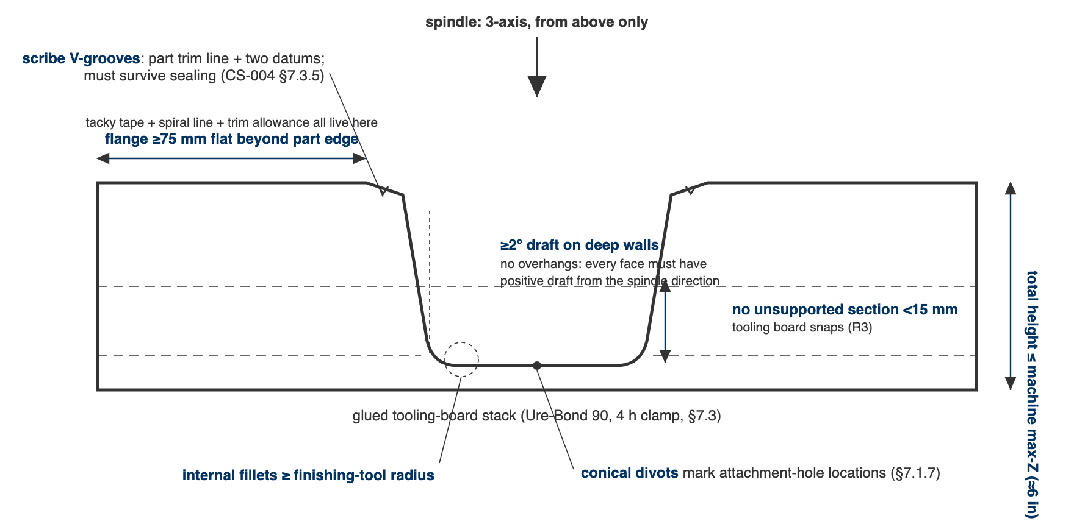
Figure 1. The §7.1 design rules dimensioned on a mold section: flange width, draft, minimum section, fillets, scribes, and the max-Z ceiling, all from the one spindle direction that exists.

7.2 Design review: the blocker (PP-03)
- Before any stock is glued or any slot booked, a reviewer who is NOT the mold's designer walks this checklist against the CAD (10 minutes):
# | Check
1 | Part surface matches current part CAD revision (open both; overlay)
2 | Flanges ≥75 mm all around
3 | Scribe + datum lines present
4 | No overhangs / negative draft from machining direction
5 | No sections <15 mm; internal fillets ≥ tool radius
6 | Height ≤ machine max-Z (value in CS-005 §5), or splits + alignment features designed
7 | Stock size exists (check inventory) and stack plan drawn
8 | Machining time estimate written on the WO
9 | Stack frozen per CS-002 §7.2 (mold offsets depend on it)

- Reviewer initials the WO "Mold design review" step. No initials, no glue, no booking.
[ PHOTO: reviewer overlaying mold CAD on part CAD, checklist on screen ]

7.3 Stock gluing
- Dry-fit boards; mark orientation. Faces must be dust-free (compressed air + IPA wipe).
- Ure-Bond 90 per R1: mix per TB, spread thin/even on one face, mate, clamp evenly, 4 h clamp minimum; full cure per TB before machining. For stacks >3 boards or very large molds: dowels + spot resin alternative (R2).
- Mark the stack immediately, in oil-based paint marker, 15 mm characters, on two adjacent side faces: part name, WO, and the up-direction (CS-001 §7.4). Mark faces the toolpath will remove less than 6 mm from, or mark the bottom.
⚠ CAUTION: A Sharpie does not survive here. Between glue-up and the CNC slot a glued block sits on a shelf beside three other glued blocks, gets clamped, weighted and IPA-wiped, and the shop's own isopropyl dissolves a Sharpie mark. This is the highest-confusion and lowest-cost-to-fix moment in the whole mold process.

7.4 Machine, clean, seal
- Machine per CS-005 (zeroing rules live there).
- Clean and seal per CS-004. Update the WO mold record (layers, density, sealing, location).

8. Quality checks / acceptance criteria
Check | Target | Method | Record where
Design review complete | Checklist initialed before gluing | WO blocker step | WO
Glue lines | No visible gaps; no board shift | Visual after clamping | WO step
Machined surface | No steps at section joints > 0.5 mm; scribes crisp | Visual + fingernail | WO qualityChecks
Machining time actual vs estimate | Recorded (feeds future planning, PP-06) | Machine log | WO

9. Records
WO mold block: stack plan, adhesive + clamp time, review checklist initials, machining estimate vs actual, photos at glue-up and after machining.

Appendix A: 3D-printed compression (forged CF) molds
From the SN5 Forged/Compression Molded Carbon Fiber study: PLA/PETG molds (40–50% infill, 4–5 walls, 0.1 mm layers) are free at Jacobs but deform/crack at ~50–100 psi and soften at 60–100 °C, with no hydraulic press and no heated cure. Design: piston-into-cavity, stroke ≈ 2× part depth, 0.1 mm sliding-face offset, chamfered split points for wedging, vent grooves against hydrolock. Clamp math: four 600 lbf trigger clamps ≈ 2,400 lbf spread over the part area → ~150 psi at 4×4 in (16 in²) but only ~37 psi at 8×8 in (64 in²). Read the two limits together: parts must be small (≲16–25 in²) for clamps to even reach the 50–100 psi consolidation target, and at exactly those pressures a printed mold is at its cracking threshold. So for small forged parts, always distribute the load with through-bolts + aluminum backup plates rather than bare trigger clamps (whose pads also relax over time); for anything larger, clamps cannot reach target pressure at all, so redesign, or accept low-pressure quality. First-part failure mode to avoid: resin starvation (see CS-008 mix math).

